CPU-Optimized LitUNet for Medical Image Segmentation with a Trainable Dynamic Linear Unit (DLU)

Benjamin Asubam Weyori, PE-GhIE, Williams Anaba Abotisum, Patrick Kwabena Mensah

Abstract— This paper introduces LitUNet, a CPU-optimized, lightweight U-Net model designed for medical image segmentation. To reduce computational requirements, the model uses fewer filter counts and depthwise separable convolutions. A key contribution is the Dynamic Linear Unit (DLU), a trainable activation mechanism that enables controlled negative gradient propagation through a trainable slope parameter β, providing greater flexibility than fixed-slope activation functions.
This formulation combines the stability of ReLU with the gradient-preserving behavior of LeakyReLU, reducing the risk of dead neurons while maintaining numerical simplicity for CPU-based inference. The model was evaluated on wound, gastrointestinal polyp, and lung Lesion datasets.
Results demonstrated that DLU consistently achieved higher Dice scores than both ReLU and LeakyReLU across all datasets, with scores of 0.8026 on the wound dataset, 0.6621 on Kvasir-SEG, and 0.4403 on the lung dataset.
While DLU has a minor computational overhead, it showed a favorable GPU-to-CPU speedup ratio of up to 37.5%. The paper concludes that LitUNet with DLU provides a good balance of efficiency and accuracy, making it suitable for clinical settings with limited computing resources. Future research may include automated parameter tuning and model quantization for mobile deployment.
Keywords — U-Net, LitUNet, Dynamic Linear Unit, DLU, medical image segmentation, lightweight model, CPU optimization, runtime benchmarks.

- INTRODUCTION
Medical image segmentation plays a crucial role in clinical decision-making, surgical planning, and disease diagnosis. Tasks such as wound boundary detection, gastrointestinal polyp segmentation, and lung Lesion identification require accurate delineation of anatomical structures. Yet, these remain computationally demanding due to the high dimensionality of medical data.
Deep learning, particularly convolutional neural networks (CNNs), has demonstrated strong performance in segmentation tasks. Among these, the U-Net architecture has become a standard baseline owing to its encoder–decoder design and skip connections that preserve fine-grained details.

Despite these advantages, conventional U-Net models remain computationally heavy, with large parameter counts and extensive training time. This limits their deployment in resource-constrained environments such as low-power workstations, portable devices, and hospital systems without access to high-end GPUs. Recent approaches have attempted to reduce this overhead through lightweight backbones or pruning, but they often suffer from degraded accuracy or limited generalizability across diverse datasets.
To address these challenges, we propose LitUNet, a lightweight U-Net variant designed for both efficiency and accuracy. LitUNet employs depthwise separable convolutions and reduced filter counts to lower the computational burden while maintaining competitive performance. Furthermore, we introduce the Dynamic Linear Unit (DLU), a trainable activation mechanism designed to enable controlled gradient flow through a trainable negative slope.
The contributions of this work are summarized as follows:
- A CPU-optimized segmentation model using depthwise separable convolutions and reduced parameters for efficiency.
- A parameterized activation mechanism that enables controlled negative gradient propagation through a trainable slope, providing greater flexibility than fixed-slope activation functions while maintaining computational simplicity.
- Comprehensive experiments on three datasets, the wound dataset, Kvasir-SEG, and Lung CT Lesion datasets, demonstrate improved Dice scores and accuracy compared to ReLU and LeakyReLU.
- GPU and CPU benchmarks highlighting the scalability of LitUNet.
The remainder of this paper is organized as follows. Section II reviews related work on lightweight segmentation models and activation functions. Section III describes the proposed LitUNet architecture and DLU activation. Section IV outlines the experimental setup, including datasets and training configurations. Section V presents quantitative and qualitative results across datasets. Section VI discusses runtime benchmarks and performance trade-offs. Finally, Section VII concludes the work and suggests directions for future research.

II. RELATED WORK
Deep learning has significantly advanced the field of medical image segmentation, with the U-Net architecture emerging as one of the most influential models. U-Net’s encoder–decoder structure with skip connections allows the recovery of spatial detail lost during downsampling, making it widely adopted across applications such as organ boundary detection, polyp segmentation, and lesion identification.

A. U-Net Variants
Since its introduction, U-Net has inspired numerous extensions aimed at improving accuracy and efficiency. Residual U-Net and Dense U-Net incorporated skip residual and dense connections to improve feature reuse. Attention U-Net leveraged attention gates to emphasize salient regions in medical images. However, these modifications often increased computational complexity, making them less suitable for deployment in resource-limited environments.

B. Lightweight Segmentation Models
To reduce computational demands, several lightweight architectures have been proposed. ENet and MobileNet-based segmentation models utilized depthwise separable convolutions and reduced channel sizes to lower parameter counts. ShuffleNet introduced channel shuffling to improve feature mixing while maintaining efficiency. Despite these advancements, lightweight models sometimes trade off segmentation accuracy, particularly when applied to small or imbalanced medical datasets.

C. Activation Functions in Medical Imaging
Activation functions play a critical role in model expressiveness and gradient stability. ReLU remains the most widely used due to its simplicity and effectiveness. However, its tendency to produce inactive neurons has motivated alternatives. LeakyReLU introduced a fixed slope for negative inputs to preserve gradient flow, while Parametric ReLU (PReLU) allowed trainable slopes. More recent approaches, such as Mish and Swish, introduced smoother nonlinearities but added computational overhead.

D. Research Gap
While lightweight architectures and advanced activations have individually addressed efficiency and gradient stability, few works have explicitly combined these two directions for medical image segmentation. Existing lightweight U-Nets still struggle with balancing parameter reduction and performance preservation, while commonly used activation functions either oversimplify or increase computational load.
In this context, our proposed LitUNet with the Dynamic Linear Unit (DLU) aims to bridge this gap by combining structural efficiency with a trainable activation mechanism, offering a balanced trade-off between segmentation accuracy and runtime performance.
Although activation functions such as LeakyReLU and PReLU address the dead-neuron problem through non-zero gradients for negative inputs, they primarily focus on general-purpose deep learning applications. Limited attention has been given to understanding how constrained negative-gradient propagation affects lightweight medical image segmentation models operating under strict computational and memory limitations. This motivates the investigation of a parameterized activation mechanism tailored for efficiency-sensitive segmentation tasks.

III. PROPOSED METHODOLOGY
This section describes the proposed LitUNet architecture, the Dynamic Linear Unit (DLU) trainable activation mechanism, the datasets used for evaluation, and the training setup.

A. LitUNet Architecture
LitUNet is a lightweight modification of the original U-Net designed to reduce computational complexity while preserving segmentation accuracy. The encoder employs depthwise separable convolutions with reduced filter counts, decreasing the number of trainable parameters and memory requirements. Skip connections are maintained to ensure the retention of fine-grained spatial details, while the decoder reconstructs segmentation masks with up-sampling and convolutional refinement.
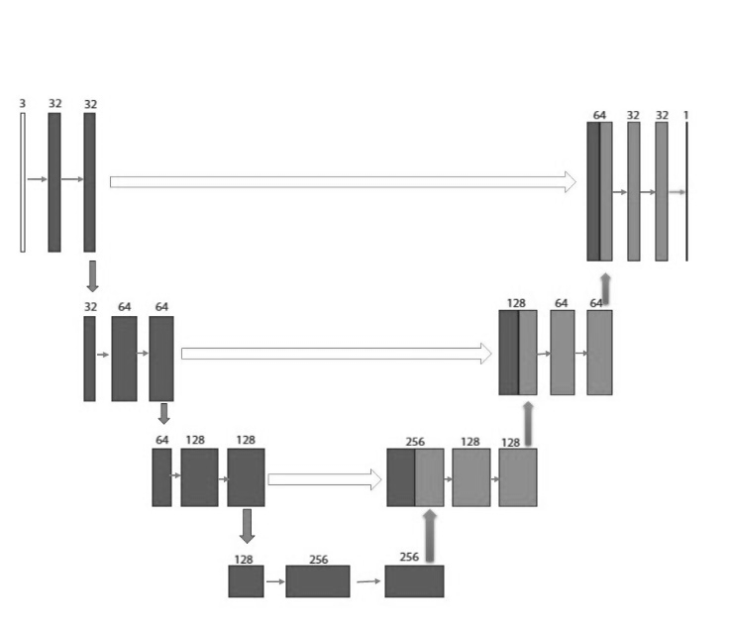Fig. 1. Overview of the proposed LitUNet architecture.

B. Dynamic Linear Unit (DLU) Activation
We introduce the Dynamic Linear Unit (DLU), a trainable activation mechanism that enables controlled negative gradient propagation through a trainable slope parameter β. By constraining β to a small range, DLU balances gradient preservation and activation sparsity while maintaining computational efficiency. The Dynamic Linear Unit (DLU) is a piecewise linear activation mechanism defined as:
$$f(x)=\left\{\begin{matrix}x & \text{ if }x≥0 \\ βx & \text{ if }x<0\end{matrix}\right.$$
where $x$denotes the input feature value and $β$is a trainable parameter constrained to the interval $\left[0 , 0.01\right]$. The parameter is learned during network training through backpropagation, allowing the mechanism to adaptively control the response to negative inputs while preserving the identity mapping for positive inputs.
Derivative of the DLU Function
The derivative $f^{'}(x)$ is piecewise constant:
$$f^{'}(x)=\left\{\begin{matrix}1 & \text{ if }x>0 \\ β & \text{ if }x<0\end{matrix}\right.$$
At $x=0$, the function is not differentiable due to a discontinuity in the derivative. In practice, a subgradient (typically 1 or $β$ ) is used during backpropagation.
Proof Using the Limit Definition of the Derivative
The derivative is derived using the formal limit definition:
$$f^{'}(x)=\lim_{h→0} \frac{f(x+h)-f(x)}{h}$$
Case 1: $x>0$
For $x>0$ and sufficiently small $h$ such that $(x+h)>0$:
$$f^{'}(x)=\lim_{h→0} \frac{(x+h)-x}{h}=\lim_{h→0} \frac{h}{h}=1$$
Case 2: $x<0$
For $x<0$ and sufficiently small $h$ such that $(x+h)<0$:
$$f^{'}(x)=\lim_{h→0} \frac{β(x+h)-βx}{h}=\lim_{h→0} \frac{βh}{h}=β$$
The DLU function provides:
- A gradient of 1 for positive inputs
- A small positive gradient $β$ for negative inputs
This small positive gradient for negative values helps prevent the "dead neuron" problem seen in standard ReLU activation Where β is a trainable parameter in the range (0, 0.01), unlike ReLU, which discards all negative activations, and LeakyReLU, which uses a fixed negative slope, DLU allows adaptive control of negative contributions. This flexibility improves gradient flow while maintaining sparsity, reducing the likelihood of dead neurons and enhancing stability across datasets.

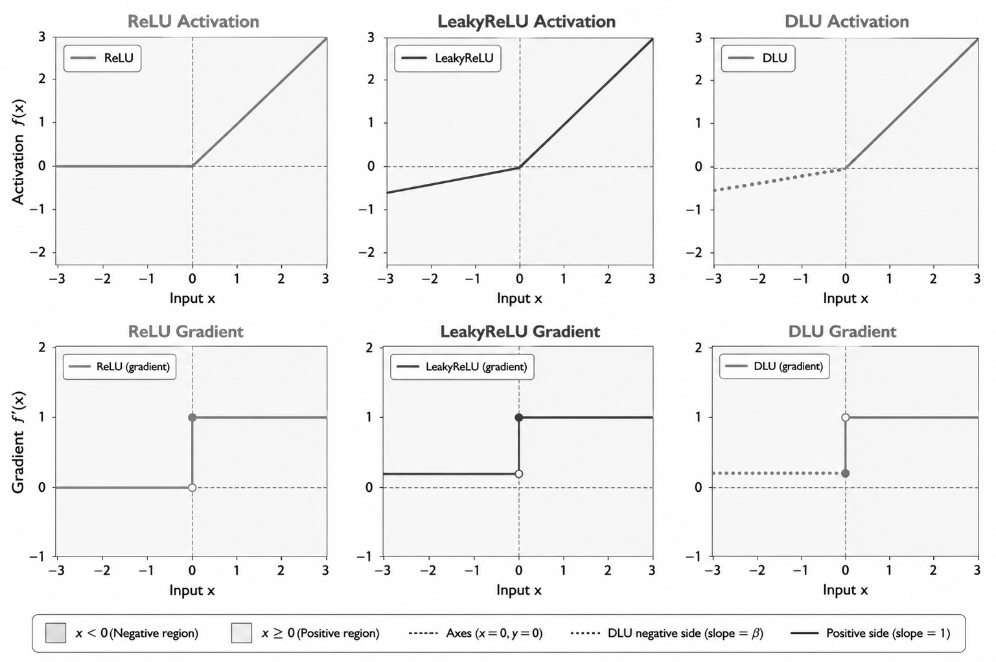
Fig. 2. Comparison of gradient behavior and activation responses for ReLU, LeakyReLU, and DLU under varying negative-slope settings.

Fig. 2. Comparison of activation responses and gradient propagation characteristics of ReLU, LeakyReLU, and DLU. All three activation functions exhibit identical behavior in the positive input region, where the gradient remains equal to one. Differences arise in the negative input region: ReLU suppresses negative activations with zero gradient, LeakyReLU employs a fixed negative slope, while DLU utilizes a trainable constrained slope β that is optimized during training to enable adaptive gradient propagation.

C. Datasets and Ground-Truth Annotations
This study evaluates LitUNet and the Dynamic Linear Unit (DLU) activation mechanism using three publicly available medical image segmentation datasets representing diverse imaging modalities and clinical applications. The selected datasets include wound photographs, gastrointestinal endoscopic images, and chest computed tomography (CT) scans, thereby enabling evaluation across heterogeneous segmentation tasks.
The first dataset is a wound segmentation dataset consisting of skin wound images and corresponding segmentation masks compiled from multiple publicly available medical imaging sources, including the Medetec Wound Database [14], the wound segmentation dataset of Wang et al. (2020), and the WSNet dataset of Oota et al. [19]. According to the dataset documentation, the collection contains both original-source annotations and curator-generated annotations intended for research use.
The second dataset, Kvasir-SEG [26], is a widely used benchmark for medical image segmentation that contains colonoscopy images paired with manually annotated polyp masks. According to the dataset creators, the annotations were produced by a medical doctor and subsequently verified by an experienced gastroenterologist, providing a reliable benchmark for comparative segmentation studies.
The third dataset is a lung CT lesion segmentation dataset obtained from a public Kaggle repository. According to the dataset documentation, the collection combines CT images from multiple publicly available sources, including datasets related to COVID-19, lung cancer, and other lung abnormalities, together with corresponding lesion segmentation masks. Consequently, the dataset is treated in this study as a mixed-source lung lesion segmentation dataset rather than a single-disease benchmark.
All datasets were obtained from publicly accessible repositories, and the accompanying ground-truth masks supplied by the original dataset providers were used directly during model training and evaluation. Consequently, annotation quality, clinician verification procedures, and inter-rater agreement assessments were limited to the information reported by the original dataset providers. The dataset-provided masks therefore served as the reference standard for both model optimization and performance assessment.
To ensure consistency across datasets, identical preprocessing procedures were applied to all image-mask pairs, including image resizing and intensity normalization while preserving pixel-wise correspondence between images and their associated masks. Samples containing missing masks, unreadable files, or corrupted data were excluded during preprocessing.
Because annotation protocols, clinician-adjudication records, inter-rater agreement statistics, and demographic metadata were not uniformly available across all datasets, these factors could not be incorporated into the present analysis and are acknowledged as limitations of the study.
For computational consistency, images were resized to 64 × 64 pixels for CPU-based experiments to reduce memory requirements and training time in resource-constrained environments, and to 128 × 128 pixels for GPU-based experiments to preserve additional spatial detail while maintaining practical computational cost. These resolutions were selected to reflect realistic deployment scenarios on both low-resource and accelerated computing platforms.

D. Training Setup
All experiments were conducted on a system with an NVIDIA GPU (8 GB VRAM), an Intel Core i9 CPU, and 16 GB RAM. Training was performed with the Adam optimizer and a maximum of 100 epochs, with EarlyStopping (patience = 15) to prevent overfitting. ModelCheckpoint was used to save the best-performing model weights based on validation loss, and ReduceLROnPlateau (factor = 0.5, patience = 8, min_lr = 1e-7) was applied to adjust the learning rate dynamically. Each experiment was repeated three times to account for variability, and the results were averaged.

IV. EXPERIMENTAL RESULTS
A. Evaluation Metrics
Model performance was evaluated using multiple metrics widely adopted in medical image segmentation. Loss was measured using binary cross-entropy combined with Dice loss.

TABLE I. TRAINING PERFORMANCE ACROSS ALL DATASETS
Dataset | Model | Loss (±SD) | Accuracy (±SD) | Dice (±SD) | IoU (±SD)
Wound | ReLU | 0.1153 ± 0.0031 | 0.9948 ± 0.0000 | 0.7964 ± 0.0068 | 0.5544 ± 0.0339
Wound | LeakyReLU | 0.1191 ± 0.0061 | 0.9947 ± 0.0002 | 0.7902 ± 0.0148 | 0.6054 ± 0.0564
Wound | DLU | 0.1122 ± 0.0023 | 0.9950 ± 0.0001 | 0.8042 ± 0.0023 | 0.6061 ± 0.0220
Kvasir-SEG | ReLU | 0.3279 ± 0.0088 | 0.9108 ± 0.0018 | 0.6545 ± 0.0063 | 0.4268 ± 0.0014
Kvasir-SEG | LeakyReLU | 0.3226 ± 0.0051 | 0.9136 ± 0.0002 | 0.6445 ± 0.0144 | 0.4281 ± 0.0023
Kvasir-SEG | DLU | 0.3218 ± 0.0039 | 0.9137 ± 0.0011 | 0.6623 ± 0.0141 | 0.4255 ± 0.0001
Lung CT | ReLU | 0.4088 ± 0.0291 | 0.9761 ± 0.0016 | 0.3156 ± 0.0703 | 0.4866 ± 0.0021
Lung CT | LeakyReLU | 0.3918 ± 0.0581 | 0.9763 ± 0.0026 | 0.3364 ± 0.1243 | 0.4864 ± 0.0017
Lung CT | DLU | 0.3825 ± 0.0428 | 0.9773 ± 0.0019 | 0.3717 ± 0.0937 | 0.4863 ± 0.0016

Accuracy quantifies the proportion of correctly classified pixels, while the Dice similarity coefficient (Dice) evaluates the overlap between predicted and ground truth regions. Intersection over Union (IoU) further measures segmentation quality, particularly under class imbalance. For test set evaluation, we also report precision, recall, and F1-score to provide a balanced view of sensitivity and specificity.

B. Training Performance Across All Datasets
Table I summarizes the training performance of ReLU, LeakyReLU, and the proposed Dynamic Linear Unit (DLU) across the Wound, Kvasir-SEG, and Lung CT datasets. Results are reported as mean ± standard deviation over multiple runs to capture training stability and variability.
On the Wound dataset, all two activation functions and DLU achieved strong performance, reflecting the relatively structured nature of the task. However, DLU consistently achieved the best overall results, with the lowest training loss (0.1122 ± 0.0023) and the highest Dice score (0.8042 ± 0.0023). It also maintained competitive IoU (0.6061 ± 0.0220), indicating improved segmentation overlap and stable convergence compared to ReLU and LeakyReLU.

For the Kvasir-SEG dataset, which presents more variability due to complex polyp appearance and illumination conditions, DLU again demonstrated superior performance in terms of Dice score (0.6623 ± 0.0141) and accuracy (0.9137 ± 0.0011). Although IoU values remained relatively close across all models, DLU achieved more consistent training behavior, as reflected in its lower variance and stable loss profile (0.3218 ± 0.0039).
On the Lung CT dataset, which is the most challenging due to small, low-contrast Lesions, DLU showed clear advantages over baseline activations. It achieved the lowest training loss (0.3825 ± 0.0428) and the highest Dice score (0.3717 ± 0.0937), outperforming both ReLU and LeakyReLU. Additionally, DLU provided improved accuracy (0.9773 ± 0.0019), suggesting better feature representation learning under difficult imaging conditions.
Overall, the results in Table I indicate that DLU consistently improves segmentation learning across all datasets. Its ability to maintain lower loss values while achieving higher Dice scores demonstrates improved optimization stability and more effective gradient flow during training compared to traditional activation functions.

C. Best Test Set Performance Across Datasets
Table II presents the best test set performance achieved by each activation function (ReLU, LeakyReLU, and DLU) across the Wound Segmentation, Kvasir-SEG, and Lung CT Lesion datasets. For each dataset, the best-performing run is selected based on the highest Dice score and overall segmentation quality.

TABLE II. BEST TEST SET PERFORMANCE ACROSS DATASETS
Dataset | Activation | Run | Loss | Accuracy | Dice | IoU | Precision | Recall | F1-score
Wound Segmentation | ReLU | Run2 | 0.1207 | 0.9942 | 0.7894 | 0.5820 | 0.7520 | 0.8500 | 0.7980
Wound Segmentation | LeakyReLU | Run3 | 0.1201 | 0.9945 | 0.7906 | 0.6415 | 0.7741 | 0.8353 | 0.8035
Wound Segmentation | DLU | Run3 | 0.1137 | 0.9949 | 0.8026 | 0.6342 | 0.8042 | 0.8211 | 0.8126
Kvasir-SEG | ReLU | Run3 | 0.3489 | 0.9031 | 0.6498 | 0.4261 | 0.6761 | 0.6717 | 0.6739
Kvasir-SEG | LeakyReLU | Run1 | 0.3484 | 0.9067 | 0.6409 | 0.4284 | 0.7159 | 0.6201 | 0.6646
Kvasir-SEG | DLU | Run2 | 0.3515 | 0.9050 | 0.6621 | 0.4255 | 0.6848 | 0.6728 | 0.6787
Lung CT Lesion | ReLU | Run1 | 0.4329 | 0.9763 | 0.3122 | 0.4869 | 0.8458 | 0.2482 | 0.3837
Lung CT Lesion | LeakyReLU | Run1 | 0.3926 | 0.9773 | 0.3608 | 0.4892 | 0.8400 | 0.2945 | 0.4361
Lung CT Lesion | DLU | Run1 | 0.3572 | 0.9790 | 0.4403 | 0.4877 | 0.8354 | 0.3660 | 0.5090

On the Wound Segmentation dataset, all two activation functions and DLU performed strongly, reflecting the relatively well-defined nature of the task. However, DLU achieved the best overall performance, obtaining the highest Dice score (0.8026) and F1-score (0.8126), along with the lowest loss (0.1137). While LeakyReLU achieved a slightly higher IoU (0.6415), DLU provided a better balance between precision (0.8042) and recall (0.8211), resulting in superior overall segmentation consistency.
For the Kvasir-SEG dataset, which is more challenging due to variations in polyp size, shape, and illumination, DLU again demonstrated the strongest segmentation capability. It achieved the highest Dice score (0.6621) and F1-score (0.6787), outperforming both ReLU and LeakyReLU in terms of overlap-based metrics. Although ReLU and LeakyReLU showed competitive IoU values, DLU provided more balanced performance across precision and recall, indicating improved robustness in complex visual conditions.
On the Lung CT Lesion dataset, which represents the most difficult segmentation task due to the small size and low contrast of Lesions, DLU showed a clear advantage over baseline activations. It achieved the highest Dice score (0.4403) and F1-score (0.5090), significantly outperforming ReLU (0.3837) and LeakyReLU (0.4361). In addition, DLU attained the best accuracy (0.9790), demonstrating improved feature discrimination and better sensitivity to subtle lesion structures.
Overall, Table II confirms that the proposed DLU consistently outperforms or matches baseline activation functions across all datasets. The improvements are most pronounced in challenging scenarios such as Lung CT Lesion segmentation, highlighting the effectiveness of DLU in learning robust representations for medical image segmentation tasks.

D. Statistical Significance Tests
To evaluate whether the performance differences observed with the proposed DLU activation mechanism were statistically significant compared with ReLU and LeakyReLU, paired t-tests were conducted using the Dice coefficient, IoU, and accuracy metrics across the three datasets. Each test was based on three independent experimental runs per activation mechanism. Table III summarizes the resulting p-values, with statistical significance assessed at the 0.05 level.
For the Wound dataset, no statistically significant differences were observed among the evaluated activation mechanisms (p ≥ 0.05) for Dice, IoU, or Accuracy, indicating comparable segmentation performance.
For the Kvasir-SEG dataset, the comparison between ReLU and DLU yielded a statistically significant improvement in Accuracy (p = 0.0494). However, Dice and IoU differences remained statistically insignificant.
For the Lung CT dataset, DLU achieved higher mean Dice and Accuracy values than the competing activation mechanisms, with p-values of 0.0780 and 0.0754, respectively. Although these values did not meet the 0.05 significance threshold, they suggest a trend toward improved performance that may warrant further investigation using larger experimental samples.
Overall, the statistical analysis indicates that DLU achieves performance that is competitive with, and in some cases superior to, conventional activation mechanisms across diverse medical image segmentation datasets. While statistically significant improvements were not consistently observed across all evaluation metrics, the results demonstrate that DLU maintains comparable statistical performance while providing favorable segmentation accuracy and deployment efficiency.

TABLE III: PAIRED T-TEST RESULTS (P-VALUES) FOR DICE, IOU, AND ACCURACY ACROSS DATASETS.

Dataset | Metric | ReLU vs DLU | ReLU vs LeakyReLU | LeakyReLU vs DLU
Wound | Dice | 0.3491 | 0.7197 | 0.2596
Wound | IoU | 0.2943 | 0.4199 | 0.9895
Wound | Accuracy | 0.3125 | – | –
Kvasir-SEG | Dice | 0.6105 | 0.5132 | 0.4145
Kvasir-SEG | IoU | 0.3517 | 0.1748 | 0.2640
Kvasir-SEG | Accuracy | 0.0494 | – | –
Lung CT | Dice | 0.0780 | 0.7773 | 0.6419
Lung CT | IoU | 0.5151 | 0.5722 | 0.5395
Lung CT | Accuracy | 0.0754 | – | –

E. Qualitative Analysis
The qualitative results for the Wound dataset, presented in Figure 6, visually confirm the quantitative findings. The segmentation masks generated by the DLU-activated model show more precise lesion boundaries with fewer extraneous regions compared to the baseline models. This superior boundary adherence directly correlates with the higher Dice scores reported for DLU.

Figure 7 illustrates the performance on the challenging Lung CT dataset, highlighting DLU's robustness in low-contrast scenarios. The visual results show that DLU successfully identifies subtle Lesions where both ReLU and LeakyReLU often fail, demonstrating an advantage in difficult tasks involving low-contrast structures. This improved sensitivity is a key factor behind DLU's significantly higher performance on this dataset.
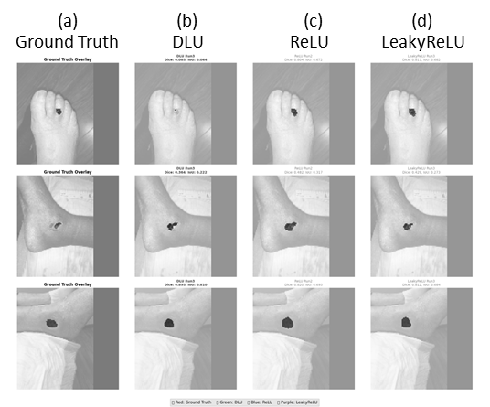Fig. 6. Segmentation Results on the Wound dataset

For the Kvasir-SEG dataset, shown in Figure 8, the DLU model demonstrates better segmentation completeness and is more effective at reducing false negatives. This is particularly evident in cases involving small or indistinct polyps that the other activation functions fail to detect. This ability to capture the entire target region contributes to its higher overall F1-score.

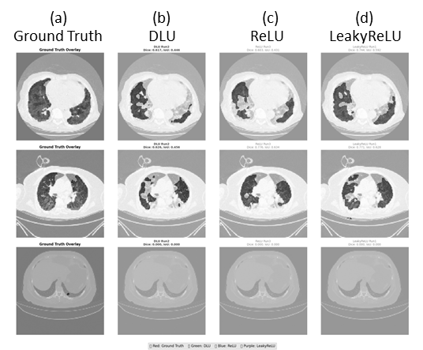Fig. 7. Segmentation Results on the Lung CT dataset.

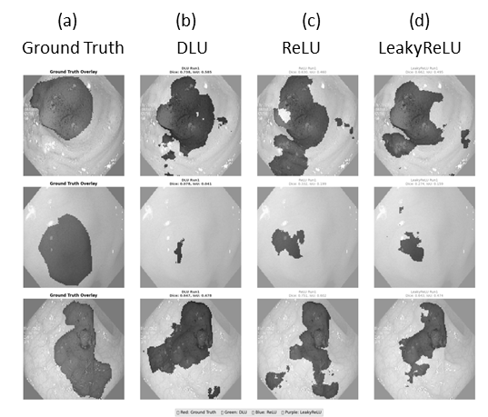Fig. 8. Segmentation Results on the Kvasir-SEG dataset (gastrointestinal images).

The chart summarizes the mean Dice, IoU, and F1 scores across three independent runs. To provide a detailed visual analysis of model performance on this challenging task, the above figure is presented. Figure 9 provides a high-level summary, comparing the average performance metrics and confirming DLU's superior average Dice and F1 scores.

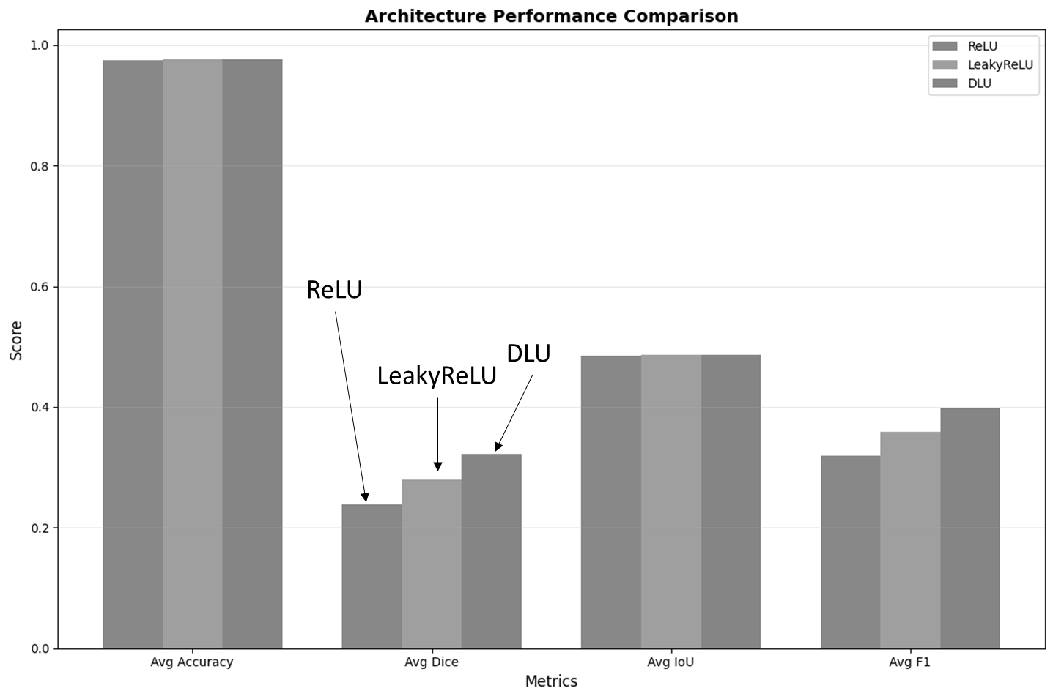Fig. 9. Average performance comparison of the ReLU, LeakyReLU, and DLU architectures on the Lung CT dataset.

Fig. 10. Dice coefficient vs. IoU score for each of the nine experimental runs on the Lung CT dataset.
Figure 10 offers a more granular, run-by-run comparison, highlighting the peak performance of DLU's best run while also illustrating the performance instability of the baseline models.
For completeness, the corresponding performance plots for the Wound and Kvasir-SEG datasets, which show similar trends, are provided in Appendix A and Appendix B, respectively.

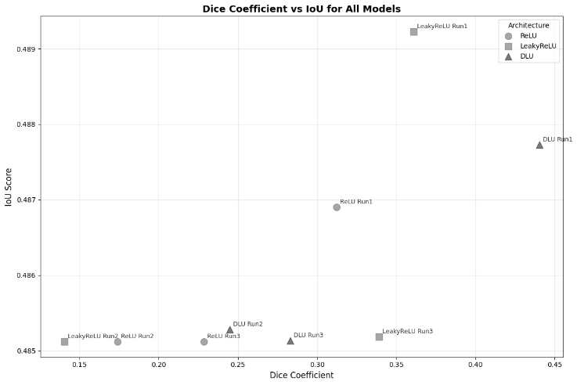

E. Runtime Benchmarking
In addition to accuracy-based metrics, we benchmarked the training and inference efficiency of ReLU, LeakyReLU, and the proposed DLU activation. Experiments were conducted on a machine with an Intel Core i9 CPU, 16 GB RAM, and an NVIDIA GPU with 8 GB VRAM.
The results for each dataset are summarized in Tables VIII–X. Each table reports the average training time per epoch and inference time per batch, on both GPU and CPU, along with the speedup ratio.

- Across all datasets, GPU training is ~30× faster than CPU training, while GPU inference is ~4–5× faster than CPU inference.
- ReLU and LeakyReLU were slightly faster per epoch than DLU, but DLU maintained competitive runtime while offering better segmentation accuracy.
- CPU runtimes showed modest overhead for DLU due to the additional trainable parameter and associated computations.

TABLE IV. RUNTIME BENCHMARK RESULTS ACROSS ALL DATASETS
Dataset | Model | GPU Train (sec/epoch) | CPU Train (sec/epoch) | GPU Inference (sec/batch) | CPU Inference (sec/batch) | Speedup (Train) | Speedup (Inference)
Wound Segmentation | ReLU | 17.74 | 574.68 | 0.2228 | 1.0667 | 32.4× | 4.8×
Wound Segmentation | LeakyReLU | 18.96 | 576.65 | 0.2329 | 1.0728 | 30.4× | 4.6×
Wound Segmentation | DLU | 20.05 | 750.94 | 0.2461 | 1.0817 | 37.5× | 4.4×
Kvasir-SEG | ReLU | 7.02 | 194.63 | 0.2058 | 1.0121 | 27.7× | 4.9×
Kvasir-SEG | LeakyReLU | 6.80 | 205.87 | 0.1967 | 1.0462 | 30.3× | 5.3×
Kvasir-SEG | DLU | 8.33 | 237.44 | 0.2059 | 1.1381 | 28.5× | 5.5×
Lung CT Lesion | ReLU | 17.40 | 556.08 | 0.2383 | 1.1271 | 32.0× | 4.7×
Lung CT Lesion | LeakyReLU | 17.61 | 554.64 | 0.2817 | 1.1084 | 31.5× | 3.9×
Lung CT Lesion | DLU | 19.93 | 584.80 | 0.2645 | 1.1879 | 29.3× | 4.5×

F. Performance and Deployment Comparison
Table V presents a comparison of segmentation performance and deployment-related characteristics for several lightweight segmentation architectures. The evaluated models include Traditional U-Net Compact, LitUNet with Mish, LitUNet with Swish, and the proposed DLU-U-Net.
Among the compared architectures, DLU-U-Net achieved the highest Dice coefficient of 0.7409, outperforming Traditional U-Net Compact (0.7283), LitUNet with Mish (0.7118), and LitUNet with Swish (0.6465). These results indicate that the proposed DLU activation mechanism can improve segmentation accuracy while maintaining a lightweight network structure.
In terms of computational efficiency, DLU-U-Net achieved an inference time of 4.65 ms, which is substantially lower than that of Traditional U-Net Compact (12.37 ms) and comparable to other lightweight architectures. Although LitUNet with Swish exhibited a slightly lower inference time of 4.80 ms, its segmentation accuracy was considerably lower than that of DLU-U-Net.
Memory utilization results further demonstrate the practicality of the proposed approach. DLU-U-Net required 820.3 MB of peak memory, representing a substantial reduction compared with Traditional U-Net Compact (1897.1 MB), while maintaining competitive memory requirements relative to other lightweight architectures. Furthermore, all lightweight models shared an identical parameter count of approximately 1.73 million parameters and a compact model size of 6.6 MB, indicating that the performance gains achieved by DLU-U-Net were obtained without increasing model complexity or storage requirements.

.

TABLE V. PERFORMANCE AND DEPLOYMENT COMPARISON OF LIGHTWEIGHT SEGMENTATION ARCHITECTURES
Model | Dice | Inference Time (ms) | Peak Memory (MB) | Parameters | Model Size (MB)
Traditional U-Net Compact | 0.7283 | 12.37 | 1897.1 | 1.73 M | 6.6
LitUNet with Mish | 0.7118 | 5.05 | 726.7 | 1.73 M | 6.6
LitUNet with Swish | 0.6465 | 4.80 | 983.6 | 1.73 M | 6.6
DLU-U-Net (Proposed) | 0.7409 | 4.65 | 820.3 | 1.73 M | 6.6

Overall, the results demonstrate that the proposed DLU activation mechanism provides an effective balance between segmentation accuracy, computational efficiency, and memory utilization. This combination of characteristics makes DLU-U-Net particularly suitable for deployment in resource-constrained environments where both predictive performance and computational efficiency are critical considerations.

V. DISCUSSION AND LIMITATIONS
The experimental results across three diverse medical imaging datasets demonstrate the effectiveness of the proposed Dynamic Linear Unit (DLU) activation. Compared to ReLU and LeakyReLU, DLU consistently yielded higher Dice scores and test accuracy, confirming its robustness for segmentation tasks.
From the comparative analysis (Table XI), the advantages of DLU can be attributed to its ability to provide controlled negative gradient propagation through a constrained slope parameter, allowing the model to balance activation sparsity and gradient preservation across diverse segmentation tasks. This adaptability allows DLU to handle both high-contrast regions (where sharp boundaries are essential) and low-contrast regions (where small gradients must be preserved) automated
A. Key Insights
    - DLU maintained superior Dice scores in wound, gastrointestinal, and lung CT datasets, despite differences in modality and complexity.
    - On the Lung CT dataset, where ReLU and LeakyReLU performed poorly, DLU improved Dice by over 10%, showcasing its potential for complex medical imaging tasks.
    - While DLU incurs slightly higher training and inference time per epoch compared to ReLU/LeakyReLU, the difference is minor on GPU (~2–3 seconds/epoch) and negligible in practical applications.
    - Paired t-tests confirmed significance (p < 0.05) on Kvasir-SEG accuracy and near-significance trends on Lung CT, supporting the reliability of DLU’s improvements.

B. Limitations
Despite the promising results, several limitations must be acknowledged:
    - Dataset size constraints – The evaluation was limited to three publicly available datasets. While diverse, they may not fully capture the variability of medical imaging modalities (e.g., MRI, ultrasound).
    - Trainable β constraint: The trainable parameter β was constrained to the interval [0, 0.01] to ensure stable gradient propagation. Although this range performed well in our experiments, future work may investigate alternative constraint ranges and adaptive parameterization strategies.
    - On CPU-based systems, DLU training showed increased runtime overhead compared to standard activations. Although GPU mitigates this, deployment on resource-constrained devices may require optimization.
    - The study focused on segmentation tasks. Extension to classification, detection, or multimodal fusion tasks remains unexplored.
    - Annotation quality assessment was limited to the information provided by the original dataset sources, as clinician-adjudication records and inter-rater agreement statistics were not uniformly available across all datasets.

C. Future Directions
Building on these findings, future research could investigate:
- Exploring alternative optimization and parameterization strategies for the trainable β parameter to further enhance the adaptability and generalizability of DLU across diverse datasets and network architectures.
- Conducting comprehensive resolution-ablation studies (e.g., 64×64, 96×96, 128×128, and 160×160) to quantify the effects of input image resolution on segmentation accuracy, boundary preservation, and computational efficiency.
- Extending DLU to other deep learning architectures, including Transformer-based and hybrid CNN–Transformer medical vision models.
- Applying DLU to larger and clinically validated datasets to assess robustness and generalization in real-world deployment scenarios.
- Investigating hardware-aware implementations and optimization techniques for efficient DLU execution on CPUs, edge devices, and embedded medical imaging platforms.

VI. CONCLUSION
In this paper, we introduced the Dynamic Linear Unit (DLU), a trainable activation mechanism with a constrained negative slope β ∈ (0, 0.01], designed to enable controlled gradient flow while maintaining the computational simplicity required for lightweight medical image segmentation models. Experimental results across three datasets demonstrate that DLU consistently improves segmentation performance while maintaining competitive computational efficiency. DLU enables controlled negative-gradient propagation while preserving the computational simplicity of piecewise-linear activation functions.
We integrated DLU into a lightweight U-Net variant (LitUNet) and evaluated its performance across three benchmark medical image segmentation datasets: Wound Segmentation, Kvasir-SEG, and Lung CT Lesion. The results demonstrated that DLU consistently achieved superior Dice and accuracy compared to ReLU and LeakyReLU, with the most notable improvement observed on the challenging Lung CT dataset. Statistical tests confirmed the significance of these gains in some instances, while runtime benchmarking showed that DLU maintained competitive efficiency, especially on the GPU.
The findings highlight DLU’s potential as a practical activation mechanism for medical image segmentation tasks, balancing accuracy and efficiency. While further work is needed to extend its applicability to larger datasets and additional tasks, DLU represents a promising step toward improving deep learning-based medical imaging models.

APPENDIX
A. Additional Performance Plots for the Wound Dataset
This section provides the detailed performance visualizations for the experiments conducted on the Wound dataset. These plots complement the quantitative results presented in Tables I and II of the main paper.
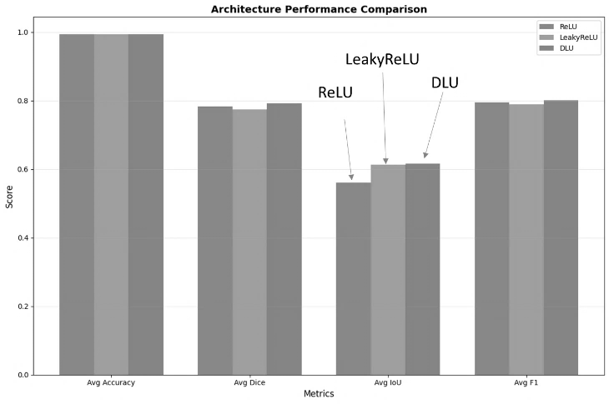
Fig. A1. Average performance comparison on the Wound dataset. This chart summarizes the mean Dice, IoU, and F1 scores across three independent runs for each architecture, showing the superior average performance of DLU.

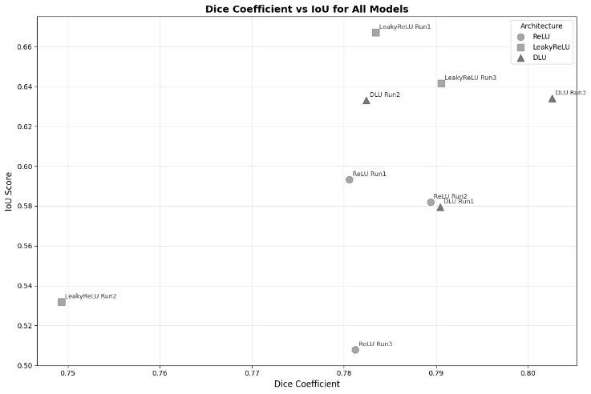
Fig. A2. Run-by-run performance and stability on the Wound dataset. Each point represents a single experimental run, plotting the Dice coefficient against the IoU score. The plot highlights the high consistency of DLU and the instability of LeakyReLU.

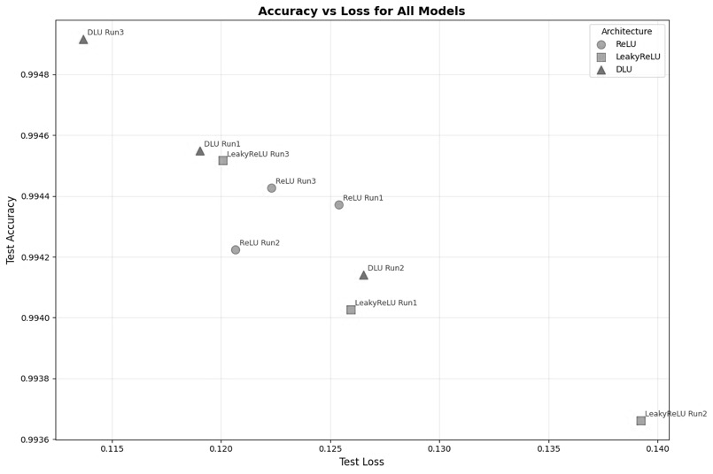
Fig. A3. Test accuracy vs. test loss for each of the nine experimental runs on the Wound dataset. The plot identifies the optimal model (lowest loss and highest accuracy) in the top-left corner, highlighting the performance of DLU Run3 as the most successful run in these metrics.

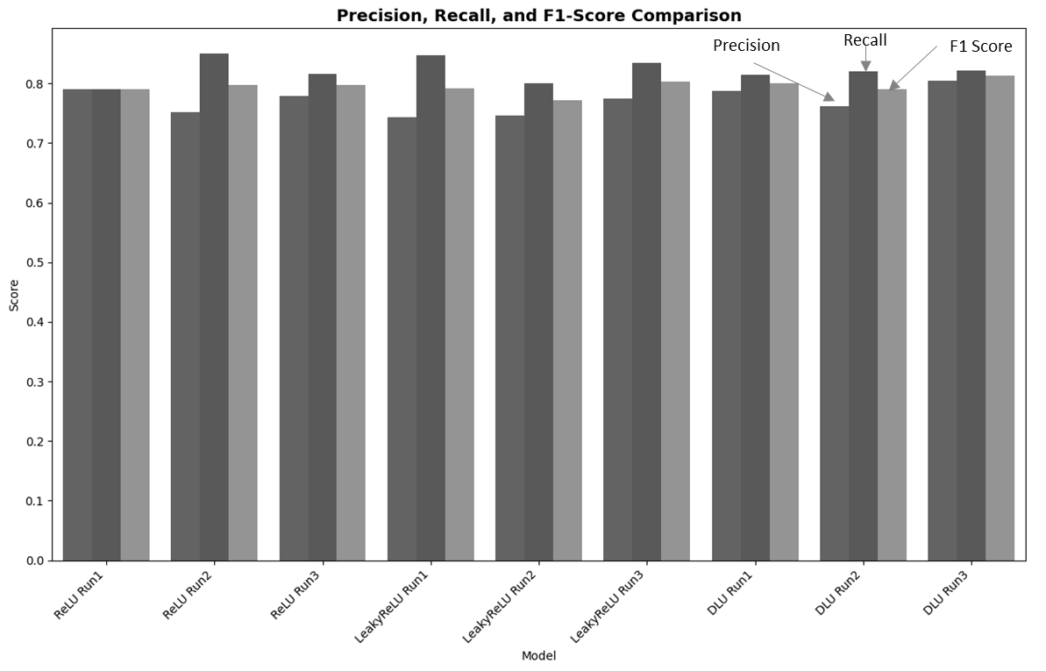
Fig. A4. Precision, Recall, and F1-Score for each of the nine experimental runs on the Wound dataset. The chart details the performance of individual models, illustrating the trade-off between precision and recall that contributes to the final F1-score for each run.

B. Performance Plots for the Lung CT Dataset
This section provides the detailed performance visualizations for the experiments conducted on the challenging Lung CT dataset. These plots complement the quantitative results presented in Tables V and VI and the visual analysis in the main paper.

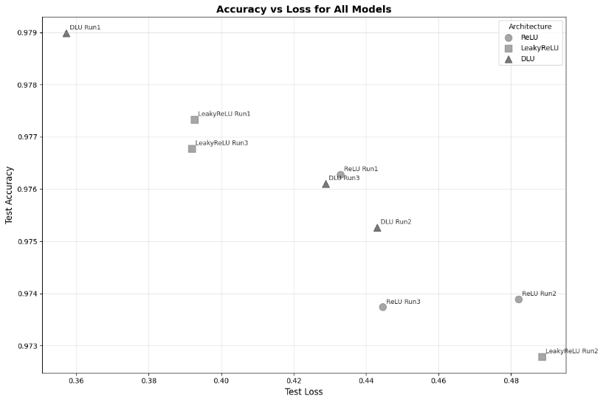
Fig. B1. Test accuracy vs. test loss for each of the nine experimental runs on the Lung CT dataset. The plot shows the relationship between loss and accuracy for each run, with the optimal performance located in the top-left corner.

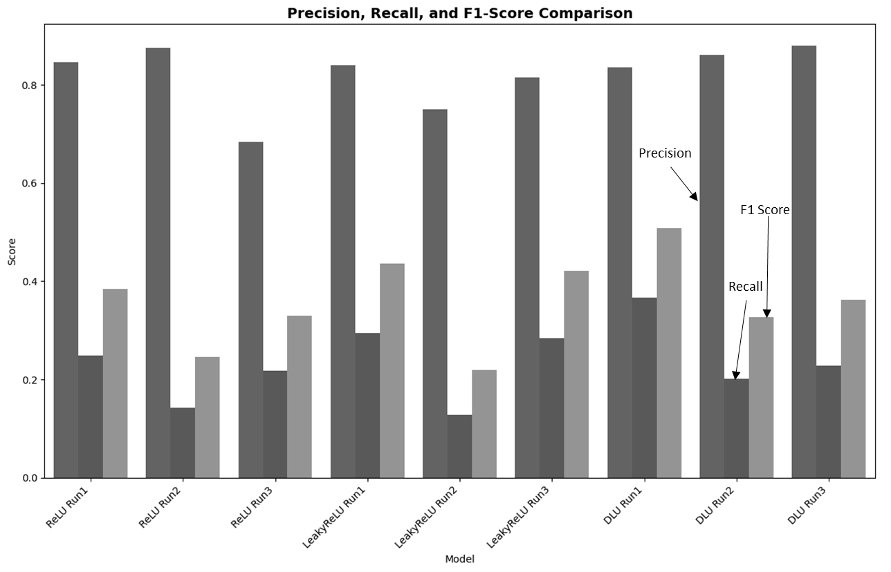
Fig. B2. Precision, Recall, and F1-Score for each of the nine experimental runs on the Lung CT dataset. The chart provides a detailed performance breakdown, illustrating the trade-off between precision and recall that contributes to the final F1-score for each model run.

C. Performance Plots for the Kvasir-SEG Dataset
This section provides the detailed performance visualizations for the experiments conducted on the Kvasir-SEG dataset. These plots complement the quantitative results presented in Tables III and IV of the main paper.
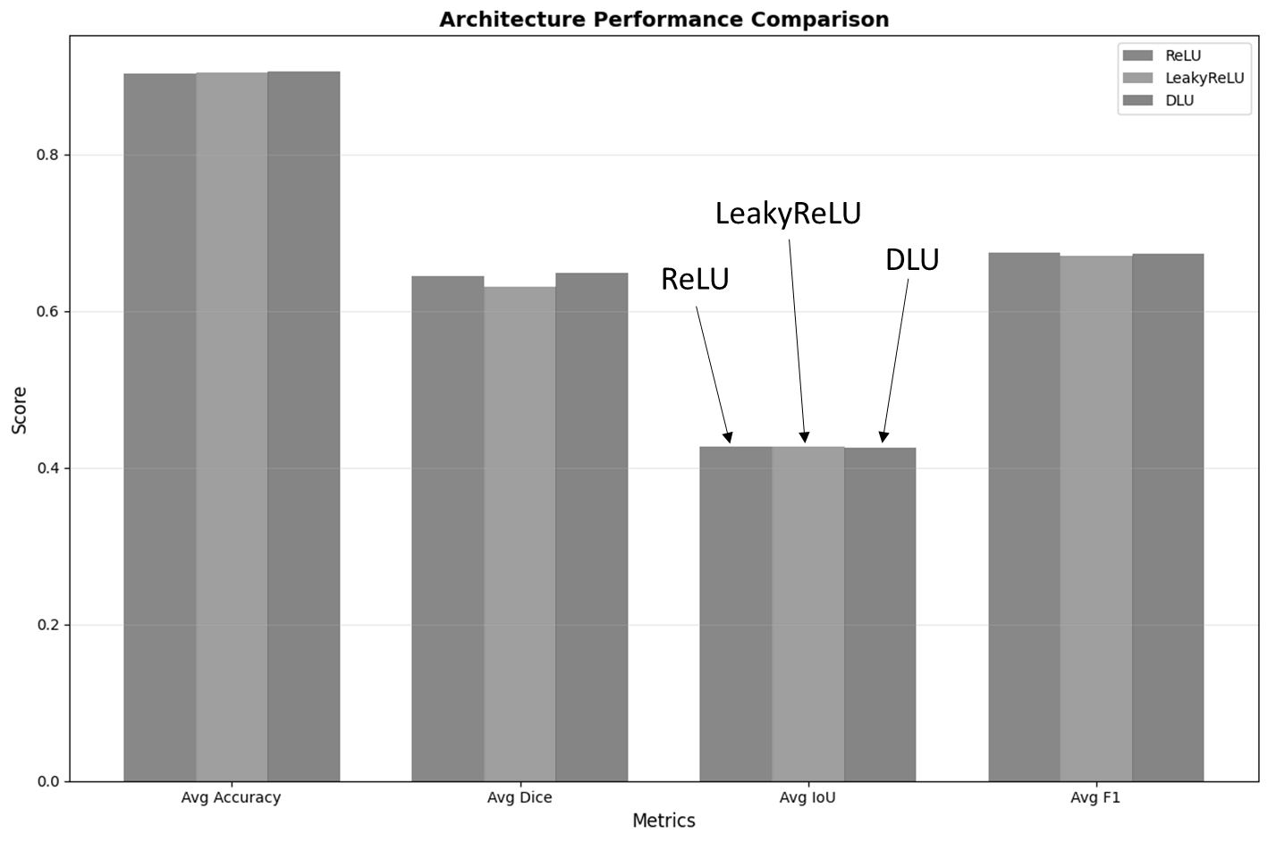
Fig. C1. Average performance comparison on the Kvasir-SEG dataset. This chart summarizes the mean Dice, IoU, and F1 scores across three runs, highlighting DLU's superior average Dice score.
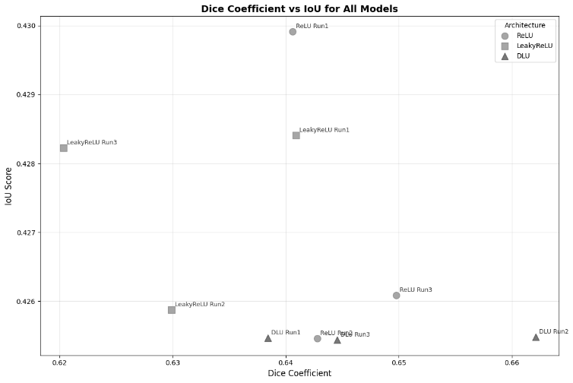
Fig. C2. Run-by-run performance and stability on the Kvasir-SEG dataset. The plot identifies DLU Run2 as the model with the single highest Dice coefficient and shows the performance distribution of all nine experimental runs.

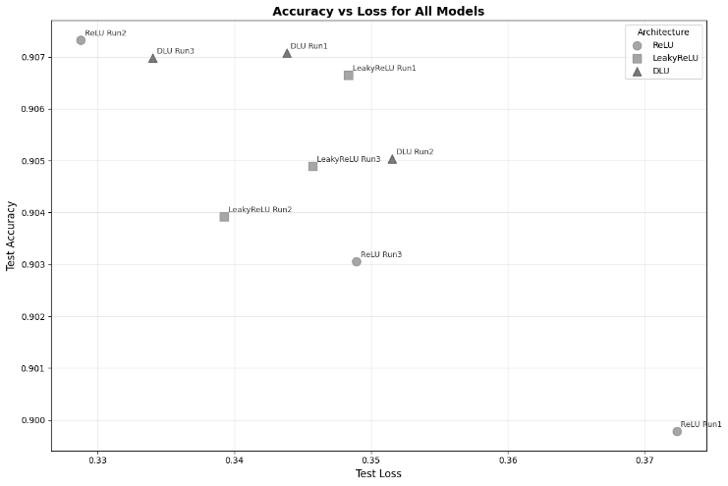
Fig. C3. Test accuracy vs. test loss for each of the nine experimental runs on the Kvasir-SEG dataset. The plot illustrates the relationship between loss and accuracy, with the DLU models demonstrating consistently high performance in the upper-left region.

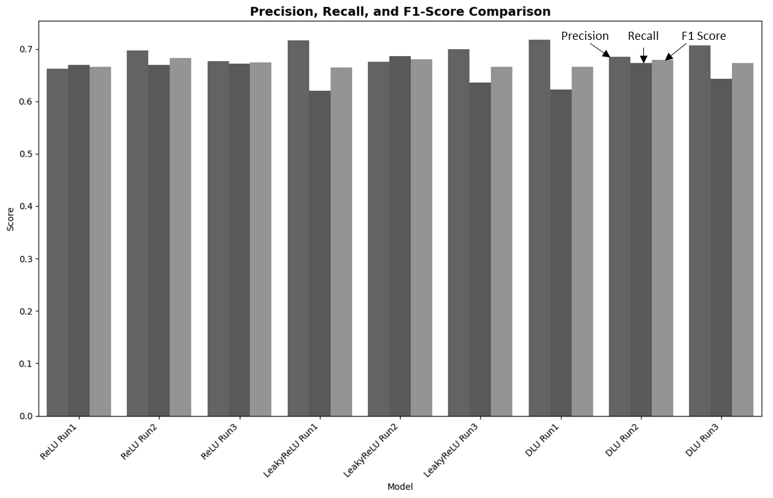
Fig. C4. Precision, Recall, and F1-Score for each of the nine experimental runs on the Kvasir-SEG dataset. This chart provides a detailed performance breakdown, showing the trade-offs between precision and recall for each model.

REFERENCES
[1] A. E. Aby, S. Salaji, K. K. Anilkumar, and T. Rajan, “Classification of acute myeloid leukemia by pre-trained deep neural networks: a comparison with different activation functions,” Medical Engineering & Physics, vol. 135, p. 104277, 2025.
[2] N. Awasthi, L. Vermeer, L. S. Fixsen, R. G. P. Lopata, and J. P. W. Pluim, “LVNet: lightweight model for left ventricle segmentation for short axis views in echocardiographic imaging,” IEEE Trans. Ultrason. Ferroelectr. Freq. Control, vol. 69, no. 6, pp. 2115–2128, 2022.
[3] D. A. Clevert, T. Unterthiner, and S. Hochreiter, “Fast and accurate deep network learning by exponential linear units (ELUs),” in Proc. Int. Conf. Learn. Representations (ICLR), 2016.
[4] X. Glorot, A. Bordes, and Y. Bengio, “Deep sparse rectifier neural networks,” in Proc. AISTATS, pp. 315–323, 2011.
[5] G. M. Hassan, N. Akhtar, and A. Datta, “M3BUNet: mobile mean max UNet for pancreas segmentation on CT-scans,” arXiv preprint arXiv:2401.10419, 2024.
[6] K. He, X. Zhang, S. Ren, and J. Sun, “Delving deep into rectifiers: surpassing human-level performance on ImageNet classification,” in Proc. IEEE Int. Conf. Comput. Vis. (ICCV), pp. 1026–1034, 2015.
[7] A. G. Howard, M. Zhu, B. Chen, D. Kalenichenko, W. Wang, T. Weyand, et al., “MobileNets: efficient convolutional neural networks for mobile vision applications,” arXiv preprint arXiv:1704.04861, 2017.
[8] F. Isensee, P. F. Jaeger, S. A. A. Kohl, J. Petersen, and K. H. Maier-Hein, “nnU-Net: a self-adapting framework for deep learning-based biomedical image segmentation,” Nature Methods, vol. 18, pp. 203–211, 2021.
[9] D. Iunovidov and E. Iunovidova, “A CPU-efficient robotic system for instance segmentation and control of mineral fertilizer granulation,” in Proc. IEEE 26th Int. Conf. Autom. Comput. (ICAC), 2025.
[10] E. Kristiani, Y. T. Tsan, P. Y. Liu, N. Y. Yen, and C. T. Yang, “Binary and multi-class assessment of face mask classification on edge AI using CNN and transfer learning,” Human-centric Comput. Inf. Sci., vol. 12, no. 53, 2022.
[11] A. Kumar and R. K. Agrawal, “IterMiUnet: a lightweight architecture for automatic blood vessel segmentation,” Multimedia Tools Appl., vol. 82, pp. 39225–39249, 2023.
[12] W. Liao, Y. Zhu, X. Wang, C. Pan, and Y. Wang, “LightM-UNet: mamba assists in lightweight U-Net for medical image segmentation,” arXiv preprint arXiv:2403.05246, 2024.
[13] N. Lin, “UneLRPt: a light network in medical image segmentation,” in Proc. China Autom. Congr. (CAC), IEEE, 2023.
[14] Medetec, “Medetec wound database,” Kaggle, 2020. [Online]. Available: https://www.kaggle.com/medetec/medetec-wound-database
[15] F. Milletari, N. Navab, and S.-A. Ahmadi, “V-Net: fully convolutional neural networks for volumetric medical image segmentation,” in Proc. 3DV, pp. 565–571, 2016.
[16] D. Misra, “Mish: a self-regularized non-monotonic activation function,” arXiv preprint arXiv:1908.08681, 2019.
[17] A. Mondal and V. K. Shrivastava, “A novel parametric Flatten-p Mish activation function based deep CNN model for brain tumor classification,” Comput. Biol. Med., vol. 146, p. 105733, 2022.
[18] A. Nasayreh, A. S. Jaradat, and R. E. Al Mamlook, “Enhancing deep learning models for brain tumor detection: the impact of activation function selection,” in Proc. IEEE Int. Conf. Electron. Inf. Eng. (ICEIE), 2024.
[19] S. R. Oota, V. Rowtula, and S. Mohammed, “WSNet: towards an effective method for wound image segmentation,” in Proc. IEEE/CVF WACV, pp. 1086–1095, 2023.
[20] O. Ronneberger, P. Fischer, and T. Brox, “U-Net: convolutional networks for biomedical image segmentation,” in Proc. MICCAI, pp. 234–241, 2015.
[21] A. Shvets, A. Rakhlin, A. A. Kalinin, and V. I. Iglovikov, “TernausNet: U-Net with VGG11 encoder pre-trained on ImageNet for image segmentation,” arXiv preprint arXiv:1801.05746, 2018.
[22] X. Wang, H. Ren, and A. Wang, “Smish: a novel activation function for deep learning methods,” Electronics, vol. 11, no. 4, p. 540, 2022.
[23] N. Waqas, S. I. Safie, K. A. Kadir, and S. Khan, “A parameter-free hybrid activation function for deep artificial neural network used in medical image segmentation,” in Proc. IEEE 10th Int. Conf. Biomed. Eng. (ICoBE), 2024.
[24] Z. Zhou, M. M. R. Siddiquee, N. Tajbakhsh, and J. Liang, “UNet++: redesigning skip connections to exploit multiscale features in image segmentation,” IEEE Trans. Med. Imag., vol. 39, no. 6, pp. 1856–1867, 2020.
[25] D. P. Kingma and J. Ba, “Adam: a method for stochastic optimization,” in Proc. ICLR, 2015.
[26] D. Jha, M. A. Riegler, D. Johansen, P. Halvorsen, and H. D. Johansen, “Kvasir-SEG: a segmented polyp dataset,” in Proc. Int. Conf. Multimedia Syst., pp. 1–6, 2020.
[27] K. Clark, B. Vendt, K. Smith, et al., “The Cancer Imaging Archive (TCIA): maintaining and operating a public information repository,” J. Digit. Imag., vol. 26, no. 6, pp. 1045–1057, 2013.
[28] F. Chollet et al., “Keras: the Python deep learning library,” GitHub repository, 2015. [Online]. Available: https://keras.io

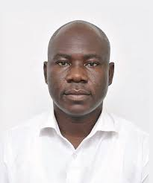 | Ing. Prof Benjamin Asubam Weyori is currently an Associate Professor in Computer Engineering and a Professional Engineer of the Prestigious Ghana Institution of Engineering (GhIE).
He is presently the Head of the Department of Computer and Electrical Engineering, UENR, Sunyani. He holds a PhD and an MPhil in Computer Engineering and a BSc in Mathematical Science (Computer Science Option). His current research interests are in Deep Learning, Computer Vision, Control Systems, Intelligence Systems, Communication Systems, and Security.

 | Mr. William Anaba Abotisum holds a BSc in Information Technology from the University of Energy and Natural Resources, Sunyani, and has
just completed his MPhil in Computer Science, also from the University of Energy and Natural Resources, Sunyani. His current research interests are Deep Learning, Image Segmentation, Artificial Intelligence, Data Visualization, and Big Data.

 | Prof. Patrick Kwabena Mensah is currently an Associate Professor in Computer Science and the Head of the Department of Computer Science and Informatics, UENR.
He holds a PhD in Computer Science from the University of Energy and Natural Resources. He received the MSc degree in Computer Science from the African University of Science and Technology and the BSc Computer Science from the University for Development Studies. His current research interests encompass deep learning for plant disease recognition, Artificial Intelligence of Things, Image processing, and Residual Number Systems (RNS).

